MediCare
Healthcare Management System
DBMS Project Report
Database: MySQL Server 8.0.16+ | Tool: MySQL Workbench 8.0+
Submitted by
Name | Aryan Vaid
UID | 25BCS10791
Partner Name | Ansh
Partner UID | 25BCS11004
Section | 802(A)
Course | Database Management Systems (Academic Project)
Session | 2026

Table of Contents
1. Abstract 3
2. Introduction 4
3. Problem Statement and Objectives 5
4. Scope of the Project 6
5. Requirement Analysis 7
6. ER Diagram 8
7. Relational Schema / Database Design 10
8. Normalization (1NF, 2NF, 3NF) 11
9. SQL Implementation (DDL, DML, DQL, TCL, DCL) 12
10. SQL Queries with Explanations and Outputs 14
11. Constraints, Joins, Subqueries and Aggregate Functions 27
12. Screenshots of Execution 28
13. Conclusion 31
14. Future Scope 32
15. References / Research Sources 33

1. Abstract
MediCare is a database-driven Healthcare Management System designed for a small hospital. It models the patient journey from registration and appointment booking through diagnosis, prescription, billing and payment. The project uses MySQL Server 8.0.16 or later and contains ten relational tables protected by primary keys, foreign keys, unique constraints and CHECK constraints. It includes 41 query/output demonstrations and executable examples of DDL, DML, DQL, TCL and DCL.
The system also provides doctor availability checking, complete patient medical history through multi-table joins, and hospital analytics such as top doctors, department-wise patient counts, monthly revenue and most prescribed medicines. All data in the project is fictional.

2. Introduction
Hospitals handle large volumes of patient, doctor, appointment and billing information. When this information is stored on paper or in scattered files it is slow to search, easy to lose and hard to analyse. A relational database stores the data once, links it through keys and answers questions quickly with SQL.
MediCare models a small hospital workflow: a new patient is registered, books an appointment with a doctor, the doctor records a diagnosis and issues a prescription, the hospital generates a bill, and the administrator retrieves histories, schedules and revenue figures.

Technology used
Component | Technology
Database | MySQL Server 8.0.16 or later
Interface | MySQL Workbench
SQL implementation | MySQL SQL scripts (10 files)
ER diagrams | Graphviz / diagrams.net
Documentation | MS Word
Repository | GitHub
Optional application | Java + JDBC

3. Problem Statement and Objectives

Problem statement
Manual record keeping in a hospital leads to duplicated data, double-booked doctors, lost prescriptions and billing errors. There is a need for a structured database that stores hospital data consistently, prevents invalid entries and allows quick retrieval of information.

Objectives
- Design a normalized relational database for hospital operations.
- Store patient, doctor, appointment, medical, prescription and billing data.
- Prevent double booking of a doctor using constraints.
- Retrieve a patient's complete medical history with JOIN queries.
- Generate analytics: busiest doctors, department-wise patients, monthly revenue, most prescribed medicines.
- Demonstrate DDL, DML, DQL, TCL and DCL commands with outputs.

4. Scope of the Project
The project covers six modules:
Module | Description
Patient Management | Register patients, update information, search records, retrieve histories
Doctor Management | Doctor details, specializations, contacts, department assignments
Appointment Management | Schedule appointments, check availability, manage status
Medical Records | Diagnoses, consultation notes, treatment history
Prescription Management | Prescriptions, medicine details, dosage and duration
Billing Management | Bills, payments, payment status

Out of scope
- Insurance claim processing, pharmacy stock, inpatient ward management and payroll.
- A graphical user interface (optional future work with Java + JDBC). This submission is a database prototype, not a production hospital application; it is intended for fictional data only.

5. Requirement Analysis

Functional requirements
- Register, update and search patients.
- Add doctors and assign them to departments.
- Book an appointment only if the doctor's slot is free; cancelling an appointment releases that slot for reuse.
- Record one diagnosis per appointment.
- Issue prescriptions with several medicines, dosage and duration.
- Generate bills for completed appointments, record one or more payments, and reconcile payment status against the total received.
- Produce administrator reports.

Non-functional requirements
- Data integrity through PRIMARY KEY, FOREIGN KEY, UNIQUE, NOT NULL, CHECK and DEFAULT.
- Normalization up to 3NF to avoid redundancy.
- Reproducible setup: scripts run in numbered order.
- Role-based access using GRANT and REVOKE.

Software and hardware requirements
Item | Requirement
Operating system | Windows 10/11, Linux or macOS
Database server | MySQL Server 8.0.16 or later
Client | MySQL Workbench 8.0 or later
RAM / disk | 4 GB RAM, 1 GB free disk

6. ER Diagram
The ER diagram shows ten entities, key attributes (PK/FK/UQ) and relationship cardinalities. G marks the generated active_status column, which is NULL for cancelled appointments and allows a cancelled slot to be reused.
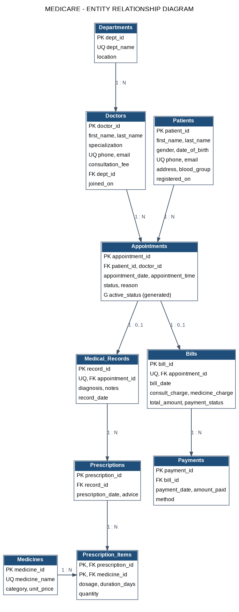

Relationships
Entity A | Relationship | Entity B | Cardinality
Departments | employs | Doctors | 1 : N
Patients | books | Appointments | 1 : N
Doctors | handles | Appointments | 1 : N
Appointments | generates | Medical_Records | 1 : 0..1
Medical_Records | has | Prescriptions | 1 : N
Prescriptions | contains | Medicines (via Prescription_Items) | M : N
Appointments | generates | Bills | 1 : 0..1
Bills | settled by | Payments | 1 : N

7. Relational Schema / Database Design
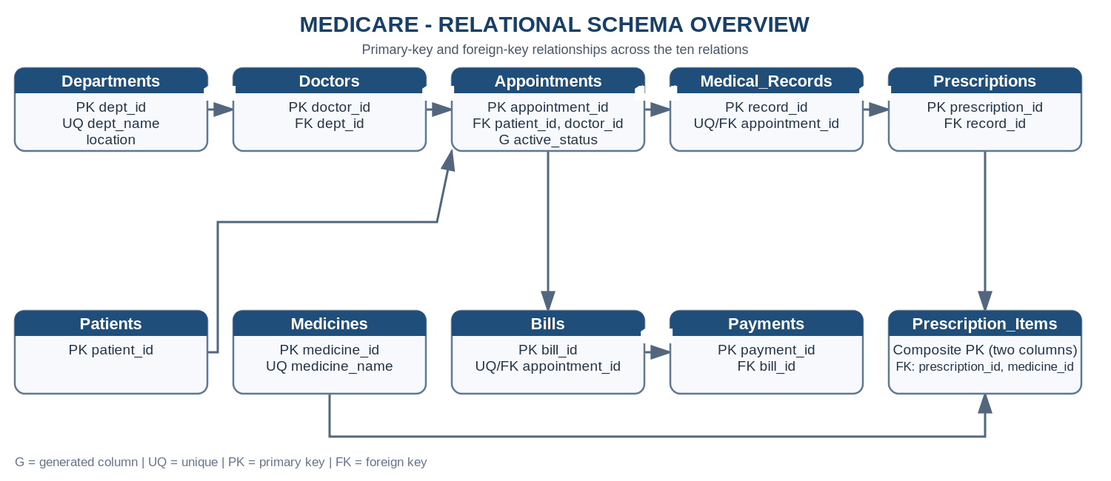
Table | Primary key | Foreign keys | Other attributes
Departments | dept_id | – | dept_name, location
Doctors | doctor_id | dept_id → Departments | first_name, last_name, specialization, phone, email, consultation_fee, joined_on
Patients | patient_id | – | first_name, last_name, gender, date_of_birth, phone, email, address, blood_group, registered_on
Appointments | appointment_id | patient_id → Patients; doctor_id → Doctors | appointment_date, appointment_time, status, reason, active_status (generated)
Medical_Records | record_id | appointment_id → Appointments | diagnosis, notes, record_date
Medicines | medicine_id | – | medicine_name, category, unit_price
Prescriptions | prescription_id | record_id → Medical_Records | prescription_date, advice
Prescription_Items | (prescription_id, medicine_id) | prescription_id → Prescriptions; medicine_id → Medicines | dosage, duration_days, quantity
Bills | bill_id | appointment_id → Appointments | bill_date, consult_charge, medicine_charge, total_amount, payment_status
Payments | payment_id | bill_id → Bills | payment_date, amount_paid, method

8. Normalization (1NF, 2NF, 3NF)

First Normal Form (1NF)
All attributes hold single atomic values and each table has a primary key. A prescription does not store a list of medicines in one column; each medicine is a separate row in Prescription_Items.

Second Normal Form (2NF)
No non-key attribute depends on only part of a composite key. In Prescription_Items (key = prescription_id + medicine_id), dosage, duration_days and quantity depend on the full key. Medicine name and price are kept in Medicines, not repeated here.

Third Normal Form (3NF)
No non-key attribute depends on another non-key attribute. Doctor details are stored only in Doctors, department details only in Departments, and patient details only in Patients; Appointments stores just their IDs. Examples of functional dependencies are patient_id -> first_name, last_name, phone; doctor_id -> first_name, specialization, dept_id; and (prescription_id, medicine_id) -> dosage, duration_days, quantity.

Design note: stored bill amounts
Bills stores consult_charge, medicine_charge and total_amount. These are derived values, kept deliberately so that a bill remains correct even if a doctor's fee or a medicine price changes later (a billing snapshot). This is a controlled exception to strict 3NF.

9. SQL Implementation (DDL, DML, DQL, TCL, DCL)
All scripts are in the SQL folder and are run in numbered order (see README.md). Scripts 01-04 build and seed the database; scripts 05-10 demonstrate queries, transactions, stored-procedure booking and permissions.
Category | File | Commands demonstrated
DDL | 01, 02, 03 | CREATE DATABASE/TABLE/INDEX/VIEW, generated column, ALTER, DROP
DML | 04, 05 | INSERT, UPDATE, DELETE
DQL | 05 – 08 | SELECT with WHERE, ORDER BY, DISTINCT, joins, subqueries, aggregates
TCL + procedure | 09 | START TRANSACTION, COMMIT, ROLLBACK, SAVEPOINT; CREATE PROCEDURE, CALL
DCL | 10 | CREATE USER, GRANT, REVOKE

DDL example: Appointments table
CREATE TABLE Appointments (
appointment_id INT AUTO_INCREMENT PRIMARY KEY,
patient_id INT NOT NULL,
doctor_id INT NOT NULL,
appointment_date DATE NOT NULL,
appointment_time TIME NOT NULL,
status ENUM('Scheduled','Completed','Cancelled') NOT NULL DEFAULT 'Scheduled',
reason VARCHAR(150),
active_status VARCHAR(10) GENERATED ALWAYS AS (
CASE WHEN status = 'Cancelled' THEN NULL ELSE 'Active' END) STORED,
CONSTRAINT fk_app_patient FOREIGN KEY (patient_id) REFERENCES Patients(patient_id)
ON UPDATE CASCADE ON DELETE RESTRICT,
CONSTRAINT fk_app_doctor FOREIGN KEY (doctor_id) REFERENCES Doctors(doctor_id)
ON UPDATE CASCADE ON DELETE RESTRICT,
CONSTRAINT uq_doctor_slot UNIQUE (
doctor_id, appointment_date, appointment_time, active_status)
);

DDL example: ALTER and DROP
-- ALTER: add a column
ALTER TABLE Patients ADD COLUMN emergency_contact VARCHAR(15);

-- ALTER: modify a column
ALTER TABLE Patients MODIFY COLUMN address VARCHAR(200);

-- ALTER: add a CHECK constraint
ALTER TABLE Patients
ADD CONSTRAINT chk_dob CHECK (date_of_birth >= '1900-01-01');

DML example
-- INSERT a new patient (patient registration step of the workflow)
INSERT INTO Patients (first_name,last_name,gender,date_of_birth,phone,email,address,blood_group)
VALUES ('Test','Patient','Other','2000-01-01','9900009999','test.patient@mail.test','Demo Address','O+');

-- UPDATE: change the new patient's phone number and address
UPDATE Patients
SET phone = '9900008888', address = 'Updated Demo Address'
WHERE phone = '9900009999';

TCL example
-- T3. SAVEPOINT: undo only part of a transaction
START TRANSACTION;

UPDATE Doctors SET consultation_fee = 850 WHERE doctor_id = 7;
SAVEPOINT after_fee_update;

UPDATE Doctors SET consultation_fee = 1 WHERE doctor_id = 8; -- wrong update
ROLLBACK TO SAVEPOINT after_fee_update; -- undo only the wrong update

COMMIT;

DCL example
-- 1. Create users (demo passwords only)
CREATE USER 'receptionist'@'localhost' IDENTIFIED BY 'Recep@123';
CREATE USER 'doctor_user'@'localhost' IDENTIFIED BY 'Doctor@123';
CREATE USER 'admin_user'@'localhost' IDENTIFIED BY 'Admin@123';

-- 2. GRANT privileges
-- Receptionist: register patients and book appointments only
GRANT SELECT, INSERT, UPDATE ON medicare_db.Patients TO 'receptionist'@'localhost';
GRANT SELECT, INSERT, UPDATE ON medicare_db.Appointments TO 'receptionist'@'localhost';
GRANT SELECT ON medicare_db.Doctors TO 'receptionist'@'localhost';

-- Doctor: read patients, write medical records and prescriptions
GRANT SELECT ON medicare_db.Patients TO 'doctor_user'@'localhost';
GRANT SELECT ON medicare_db.Appointments TO 'doctor_user'@'localhost';
GRANT SELECT, INSERT, UPDATE ON medicare_db.Medical_Records TO 'doctor_user'@'localhost';
GRANT SELECT, INSERT, UPDATE ON medicare_db.Prescriptions TO 'doctor_user'@'localhost';
GRANT SELECT, INSERT, UPDATE ON medicare_db.Prescription_Items TO 'doctor_user'@'localhost';
GRANT SELECT ON medicare_db.Medicines TO 'doctor_user'@'localhost';

-- Administrator: full control of this database
GRANT ALL PRIVILEGES ON medicare_db.* TO 'admin_user'@'localhost';

FLUSH PRIVILEGES;
Implementation note: The stored procedure checks availability, relies on the UNIQUE key as the final concurrency safeguard, and demonstrates rebooking after cancellation. Script 09 also reconciles payment_status from recorded Payments; this is an explicit update, not an automatic trigger on every payment INSERT. DCL output is shown with SHOW GRANTS (see Section 12).

10. SQL Queries with Explanations and Outputs
Each query is shown with its SQL, a short explanation and the output obtained on the sample data.

Q1. List all patients
Lists every registered patient with basic details.
SELECT patient_id, first_name, last_name, gender, phone FROM Patients

patient_id | first_name | last_name | gender | phone
1 | Aarav | Singh | Male | 9900000001
2 | Diya | Patel | Female | 9900000002
3 | Kabir | Khanna | Male | 9900000003
4 | Ishita | Gupta | Female | 9900000004
5 | Rahul | Verma | Male | 9900000005
6 | Meera | Joshi | Female | 9900000006
7 | Aditya | Reddy | Male | 9900000007
8 | Sana | Ali | Female | 9900000008
9 | Vivek | Bansal | Male | 9900000009
10 | Tanya | Chopra | Female | 9900000010
11 | Harsh | Vardhan | Male | 9900000011
12 | Pooja | Malik | Female | 9900000012
13 | Nikhil | Arora | Male | 9900000013
14 | Riya | Saxena | Female | 9900000014
15 | Manoj | Tiwari | Male | 9900000015

Q2. Patients with blood group O+
Filters patients having blood group O+ using WHERE.
SELECT patient_id, first_name, last_name, blood_group
FROM Patients
WHERE blood_group = 'O+'

patient_id | first_name | last_name | blood_group
2 | Diya | Patel | O+
8 | Sana | Ali | O+
12 | Pooja | Malik | O+
15 | Manoj | Tiwari | O+

Q3. Doctors whose consultation fee is above 700
Shows doctors whose consultation fee is greater than 700.
SELECT doctor_id, first_name, last_name, specialization, consultation_fee
FROM Doctors
WHERE consultation_fee > 700

doctor_id | first_name | last_name | specialization | consultation_fee
1 | Rohan | Mehta | Cardiologist | 800.00
2 | Anita | Sharma | Cardiologist | 900.00
3 | Vikram | Rao | Neurologist | 1000.00
4 | Sneha | Kapoor | Orthopedic Surgeon | 850.00
5 | Arjun | Nair | Orthopedic Surgeon | 750.00

Q4. Appointments that are still scheduled
Finds appointments that are still scheduled (not yet completed or cancelled).
SELECT appointment_id, patient_id, doctor_id, appointment_date, appointment_time
FROM Appointments
WHERE status = 'Scheduled'

appointment_id | patient_id | doctor_id | appointment_date | appointment_time
23 | 5 | 1 | 2026-10-20 | 09:30:00
25 | 14 | 2 | 2026-11-18 | 10:00:00

Q5. Patients registered between 1 Aug 2026 and 31 Aug 2026 (BETWEEN)
Uses BETWEEN to list patients registered in August 2026.
SELECT patient_id, first_name, last_name, registered_on
FROM Patients
WHERE registered_on BETWEEN '2026-08-01' AND '2026-08-31'

patient_id | first_name | last_name | registered_on
7 | Aditya | Reddy | 2026-08-01
8 | Sana | Ali | 2026-08-03
9 | Vivek | Bansal | 2026-08-09
10 | Tanya | Chopra | 2026-08-12
11 | Harsh | Vardhan | 2026-08-20

Q6. Search patients whose first name starts with 'A' (LIKE)
Uses LIKE with a wildcard to find patients whose first name starts with 'A'.
SELECT patient_id, first_name, last_name
FROM Patients
WHERE first_name LIKE 'A%'

patient_id | first_name | last_name
1 | Aarav | Singh
7 | Aditya | Reddy

Q7. Doctors sorted by fee, highest first (ORDER BY)
Sorts doctors by fee (highest first); ties are sorted by last name.
SELECT first_name, last_name, specialization, consultation_fee
FROM Doctors
ORDER BY consultation_fee DESC, last_name ASC

first_name | last_name | specialization | consultation_fee
Vikram | Rao | Neurologist | 1000.00
Anita | Sharma | Cardiologist | 900.00
Sneha | Kapoor | Orthopedic Surgeon | 850.00
Rohan | Mehta | Cardiologist | 800.00
Arjun | Nair | Orthopedic Surgeon | 750.00
Priya | Iyer | Pediatrician | 600.00
Karan | Malhotra | General Physician | 500.00
Neha | Verma | General Physician | 500.00

Q8. Distinct doctor specializations (DISTINCT)
DISTINCT removes duplicate specializations.
SELECT DISTINCT specialization
FROM Doctors
ORDER BY specialization

specialization
Cardiologist
General Physician
Neurologist
Orthopedic Surgeon
Pediatrician

Q9. Distinct blood groups present among patients
DISTINCT returns each blood group once.
SELECT DISTINCT blood_group
FROM Patients
ORDER BY blood_group

blood_group
A+
A-
AB+
AB-
B+
B-
O+
O-

Q10. Appointments with status Completed or Cancelled (IN)
IN selects appointments that are Completed or Cancelled; the latest five are shown.
SELECT appointment_id, appointment_date, status
FROM Appointments
WHERE status IN ('Completed','Cancelled')
ORDER BY appointment_date DESC
LIMIT 5

appointment_id | appointment_date | status
24 | 2026-10-22 | Cancelled
22 | 2026-10-15 | Completed
21 | 2026-10-10 | Completed
20 | 2026-10-06 | Completed
19 | 2026-10-01 | Completed

DML: after UPDATE
Shows the test patient after UPDATE changed phone and address.
SELECT patient_id, first_name, phone, address FROM Patients WHERE first_name = 'Test'

patient_id | first_name | phone | address
16 | Test | 9900008888 | Updated Demo Address

DML: after DELETE
Patient count after DELETE – back to 15, so sample data is unchanged.
SELECT COUNT(*) AS patients_after_delete FROM Patients

patients_after_delete
15

J1. Appointment list with patient and doctor names (INNER JOIN, 3 tables)
Joins Appointments, Patients and Doctors to display readable names instead of IDs.
SELECT a.appointment_id,
CONCAT(p.first_name,' ',p.last_name) AS patient,
CONCAT('Dr. ',d.first_name,' ',d.last_name) AS doctor,
a.appointment_date, a.status
FROM Appointments a
JOIN Patients p ON a.patient_id = p.patient_id
JOIN Doctors d ON a.doctor_id = d.doctor_id
ORDER BY a.appointment_date
LIMIT 8

appointment_id | patient | doctor | appointment_date | status
1 | Aarav Singh | Dr. Rohan Mehta | 2026-08-04 | Completed
2 | Diya Patel | Dr. Karan Malhotra | 2026-08-05 | Completed
3 | Kabir Khanna | Dr. Sneha Kapoor | 2026-08-06 | Completed
4 | Ishita Gupta | Dr. Priya Iyer | 2026-08-08 | Completed
5 | Rahul Verma | Dr. Anita Sharma | 2026-08-12 | Completed
6 | Meera Joshi | Dr. Vikram Rao | 2026-08-14 | Completed
7 | Aditya Reddy | Dr. Priya Iyer | 2026-08-18 | Completed
8 | Sana Ali | Dr. Neha Verma | 2026-08-20 | Completed

J2. Doctors with their department (INNER JOIN)
Joins Doctors with Departments to show where each doctor works.
SELECT CONCAT('Dr. ',d.first_name,' ',d.last_name) AS doctor,
d.specialization, dep.dept_name, dep.location
FROM Doctors d
JOIN Departments dep ON d.dept_id = dep.dept_id
ORDER BY dep.dept_name

doctor | specialization | dept_name | location
Dr. Rohan Mehta | Cardiologist | Cardiology | Block A
Dr. Anita Sharma | Cardiologist | Cardiology | Block A
Dr. Karan Malhotra | General Physician | General Medicine | Main Block
Dr. Neha Verma | General Physician | General Medicine | Main Block
Dr. Vikram Rao | Neurologist | Neurology | Block B
Dr. Sneha Kapoor | Orthopedic Surgeon | Orthopedics | Block C
Dr. Arjun Nair | Orthopedic Surgeon | Orthopedics | Block C
Dr. Priya Iyer | Pediatrician | Pediatrics | Block D

J3. All appointments and their bills; appointments without a bill show NULL (LEFT JOIN)
LEFT JOIN keeps all appointments; those with no bill (scheduled/cancelled) show NULL.
SELECT a.appointment_id, a.appointment_date, a.status, b.bill_id, b.total_amount
FROM Appointments a
LEFT JOIN Bills b ON a.appointment_id = b.appointment_id
WHERE b.bill_id IS NULL

appointment_id | appointment_date | status | bill_id | total_amount
23 | 2026-10-20 | Scheduled | NULL | NULL
24 | 2026-10-22 | Cancelled | NULL | NULL
25 | 2026-11-18 | Scheduled | NULL | NULL

J4. COMPLETE MEDICAL HISTORY of patient 1 (feature: Patient medical history)
Patient medical history: a seven-table JOIN from patient to appointment, diagnosis, prescription and medicines.
SELECT a.appointment_date AS visit_date,
CONCAT('Dr. ',d.first_name,' ',d.last_name) AS doctor,
mr.diagnosis,
m.medicine_name, pi.dosage, pi.duration_days
FROM Patients p
JOIN Appointments a ON a.patient_id = p.patient_id
JOIN Doctors d ON a.doctor_id = d.doctor_id
LEFT JOIN Medical_Records mr ON mr.appointment_id = a.appointment_id
LEFT JOIN Prescriptions pr ON pr.record_id = mr.record_id
LEFT JOIN Prescription_Items pi ON pi.prescription_id = pr.prescription_id
LEFT JOIN Medicines m ON m.medicine_id = pi.medicine_id
WHERE p.patient_id = 1
ORDER BY a.appointment_date

visit_date | doctor | diagnosis | medicine_name | dosage | duration_days
2026-08-04 | Dr. Rohan Mehta | Hypertension | Amlodipine 5mg | 1-0-0 | 30
2026-08-04 | Dr. Rohan Mehta | Hypertension | Aspirin 75mg | 0-1-0 | 30
2026-09-02 | Dr. Anita Sharma | Hypertension (controlled) | Amlodipine 5mg | 1-0-0 | 30

J5. Outstanding balance per bill (LEFT JOIN with Payments + GROUP BY)
Calculates the unpaid balance of every bill using LEFT JOIN, SUM, GROUP BY and HAVING.
SELECT b.bill_id, b.total_amount,
COALESCE(SUM(py.amount_paid),0) AS paid,
b.total_amount - COALESCE(SUM(py.amount_paid),0) AS balance
FROM Bills b
LEFT JOIN Payments py ON py.bill_id = b.bill_id
GROUP BY b.bill_id, b.total_amount
HAVING balance > 0

bill_id | total_amount | paid | balance
5 | 1335.00 | 667.50 | 667.50
9 | 1190.00 | 0.00 | 1190.00
13 | 1970.00 | 985.00 | 985.00
22 | 1110.00 | 0.00 | 1110.00

J6. Pairs of doctors working in the same department (SELF JOIN)
SELF JOIN pairs doctors who work in the same department.
SELECT d1.last_name AS doctor_1, d2.last_name AS doctor_2, dep.dept_name
FROM Doctors d1
JOIN Doctors d2 ON d1.dept_id = d2.dept_id AND d1.doctor_id < d2.doctor_id
JOIN Departments dep ON dep.dept_id = d1.dept_id

doctor_1 | doctor_2 | dept_name
Mehta | Sharma | Cardiology
Kapoor | Nair | Orthopedics
Malhotra | Verma | General Medicine

J7. Prescription of appointment 1: medicines, dosage and cost
Shows the medicines, dosage and line cost of the prescription issued for appointment 1.
SELECT m.medicine_name, pi.dosage, pi.quantity, m.unit_price,
pi.quantity * m.unit_price AS line_total
FROM Medical_Records mr
JOIN Prescriptions pr ON pr.record_id = mr.record_id
JOIN Prescription_Items pi ON pi.prescription_id = pr.prescription_id
JOIN Medicines m ON m.medicine_id = pi.medicine_id
WHERE mr.appointment_id = 1

medicine_name | dosage | quantity | unit_price | line_total
Amlodipine 5mg | 1-0-0 | 30 | 4.00 | 120.00
Aspirin 75mg | 0-1-0 | 30 | 1.50 | 45.00

S1. Doctors charging more than the average consultation fee
Subquery returns the average fee; the outer query lists doctors charging more.
SELECT first_name, last_name, consultation_fee
FROM Doctors
WHERE consultation_fee > (SELECT AVG(consultation_fee) FROM Doctors)

first_name | last_name | consultation_fee
Rohan | Mehta | 800.00
Anita | Sharma | 900.00
Vikram | Rao | 1000.00
Sneha | Kapoor | 850.00
Arjun | Nair | 750.00

S2. Patients who have consulted a Cardiology doctor (IN subquery)
IN subquery finds patients who have visited a Cardiology doctor.
SELECT patient_id, first_name, last_name
FROM Patients
WHERE patient_id IN (
SELECT a.patient_id
FROM Appointments a
JOIN Doctors d ON a.doctor_id = d.doctor_id
JOIN Departments dep ON d.dept_id = dep.dept_id
WHERE dep.dept_name = 'Cardiology')

patient_id | first_name | last_name
1 | Aarav | Singh
5 | Rahul | Verma
9 | Vivek | Bansal
14 | Riya | Saxena
15 | Manoj | Tiwari

S3. Patients with at least one unpaid bill (EXISTS, correlated)
Correlated EXISTS finds patients having at least one unpaid bill.
SELECT p.patient_id, p.first_name, p.last_name
FROM Patients p
WHERE EXISTS (
SELECT 1
FROM Appointments a
JOIN Bills b ON b.appointment_id = a.appointment_id
WHERE a.patient_id = p.patient_id AND b.payment_status = 'Unpaid')

patient_id | first_name | last_name
9 | Vivek | Bansal
10 | Tanya | Chopra

S4. Most expensive medicine (subquery with MAX)
Subquery with MAX finds the most expensive medicine.
SELECT medicine_name, unit_price
FROM Medicines
WHERE unit_price = (SELECT MAX(unit_price) FROM Medicines)

medicine_name | unit_price
Vitamin D3 60K | 25.00

S5. Bills above the average bill amount
Lists bills above the average bill amount.
SELECT bill_id, appointment_id, total_amount
FROM Bills
WHERE total_amount > (SELECT AVG(total_amount) FROM Bills)
ORDER BY total_amount DESC

bill_id | appointment_id | total_amount
13 | 13 | 1970.00
3 | 3 | 1670.00
5 | 5 | 1335.00
6 | 6 | 1190.00
9 | 9 | 1190.00
16 | 16 | 1115.00
22 | 22 | 1110.00
19 | 19 | 1065.00
11 | 11 | 1020.00
1 | 1 | 965.00

S6. DOCTOR AVAILABILITY CHECK (feature)
Doctor availability check: returns 'Not available' because Dr. Rohan Mehta already has an appointment at that slot.
SELECT CASE
WHEN EXISTS (SELECT 1 FROM Appointments
WHERE doctor_id = 1
AND appointment_date = '2026-08-04'
AND appointment_time = '10:00:00'
AND status <> 'Cancelled')
THEN 'Not available'
ELSE 'Available'
END AS slot_status

slot_status
Not available

S7. Doctors who have never had a cancelled appointment (NOT IN)
NOT IN lists doctors with no cancelled appointment.
SELECT doctor_id, first_name, last_name
FROM Doctors
WHERE doctor_id NOT IN (SELECT doctor_id FROM Appointments WHERE status = 'Cancelled')

doctor_id | first_name | last_name
1 | Rohan | Mehta
2 | Anita | Sharma
3 | Vikram | Rao
4 | Sneha | Kapoor
5 | Arjun | Nair
6 | Priya | Iyer
8 | Neha | Verma

S8. Patients with more appointments than the average per patient (subquery in HAVING)
Subquery inside HAVING lists patients who visited more often than the per-patient average.
SELECT patient_id, COUNT(*) AS visits
FROM Appointments
GROUP BY patient_id
HAVING COUNT(*) > (SELECT COUNT(*) / COUNT(DISTINCT patient_id) FROM Appointments)

patient_id | visits
1 | 2
2 | 2
3 | 2
4 | 2
5 | 2
6 | 2
8 | 2
9 | 2
10 | 2
14 | 2

A1. Total number of patients
COUNT of all patients.
SELECT COUNT(*) AS total_patients FROM Patients

total_patients
15

A2. Average, minimum and maximum consultation fee
AVG, MIN and MAX of consultation fees.
SELECT AVG(consultation_fee) AS avg_fee,
MIN(consultation_fee) AS min_fee,
MAX(consultation_fee) AS max_fee
FROM Doctors

avg_fee | min_fee | max_fee
737.50 | 500.00 | 1000.00

A3. Total billed amount and total amount collected
SUM of billed amount versus amount actually collected.
SELECT (SELECT SUM(total_amount) FROM Bills) AS total_billed,
(SELECT SUM(amount_paid) FROM Payments) AS total_collected

total_billed | total_collected
20731.00 | 16778.50

A4. Number of appointments by status (GROUP BY)
GROUP BY status counts appointments in each state.
SELECT status, COUNT(*) AS total
FROM Appointments
GROUP BY status

status | total
Cancelled | 1
Completed | 22
Scheduled | 2

A5. ANALYTICS: Most frequently consulted doctors
Analytics: doctors ranked by completed consultations.
SELECT CONCAT('Dr. ',d.first_name,' ',d.last_name) AS doctor,
COUNT(*) AS consultations
FROM Appointments a
JOIN Doctors d ON a.doctor_id = d.doctor_id
WHERE a.status = 'Completed'
GROUP BY d.doctor_id, d.first_name, d.last_name
ORDER BY consultations DESC, doctor
LIMIT 5

doctor | consultations
Dr. Priya Iyer | 4
Dr. Anita Sharma | 3
Dr. Karan Malhotra | 3
Dr. Neha Verma | 3
Dr. Rohan Mehta | 3

A6. ANALYTICS: Department-wise patient count (distinct patients)
Analytics: number of distinct patients per department.
SELECT dep.dept_name, COUNT(DISTINCT a.patient_id) AS patients
FROM Departments dep
JOIN Doctors d ON d.dept_id = dep.dept_id
JOIN Appointments a ON a.doctor_id = d.doctor_id
GROUP BY dep.dept_id, dep.dept_name
ORDER BY patients DESC

dept_name | patients
Cardiology | 5
General Medicine | 5
Neurology | 3
Pediatrics | 3
Orthopedics | 2

A7. ANALYTICS: Monthly revenue (payments received)
Analytics: revenue received per month.
SELECT DATE_FORMAT(payment_date,'%Y-%m') AS month,
SUM(amount_paid) AS revenue
FROM Payments
GROUP BY DATE_FORMAT(payment_date,'%Y-%m')
ORDER BY month

month | revenue
2026-08 | 7846.50
2026-09 | 6562.00
2026-10 | 2370.00

A8. ANALYTICS: Most prescribed medicines
Analytics: medicines prescribed most often.
SELECT m.medicine_name, COUNT(*) AS times_prescribed, SUM(pi.quantity) AS total_units
FROM Prescription_Items pi
JOIN Medicines m ON m.medicine_id = pi.medicine_id
GROUP BY m.medicine_id, m.medicine_name
ORDER BY times_prescribed DESC, total_units DESC
LIMIT 5

medicine_name | times_prescribed | total_units
Amlodipine 5mg | 5 | 150
Paracetamol 500mg | 5 | 49
Aspirin 75mg | 4 | 120
Cetirizine 10mg | 4 | 27
Atorvastatin 10mg | 3 | 90

A9. Doctors with at least 3 completed consultations (HAVING)
HAVING keeps only doctors with at least 3 completed consultations.
SELECT doctor_id, COUNT(*) AS consultations
FROM Appointments
WHERE status = 'Completed'
GROUP BY doctor_id
HAVING COUNT(*) >= 3

doctor_id | consultations
1 | 3
2 | 3
3 | 3
6 | 4
7 | 3
8 | 3

A10. Revenue per department (payments -> bills -> appointments -> doctors -> departments)
Revenue collected per department through a five-table join.
SELECT dep.dept_name, SUM(py.amount_paid) AS revenue
FROM Payments py
JOIN Bills b ON b.bill_id = py.bill_id
JOIN Appointments a ON a.appointment_id = b.appointment_id
JOIN Doctors d ON d.doctor_id = a.doctor_id
JOIN Departments dep ON dep.dept_id = d.dept_id
GROUP BY dep.dept_name
HAVING SUM(py.amount_paid) > 1000
ORDER BY revenue DESC

dept_name | revenue
Cardiology | 4832.50
General Medicine | 3654.00
Orthopedics | 3385.50
Pediatrics | 2731.50
Neurology | 2175.00

T1. COMMIT
A uniquely identified demo appointment is inserted and COMMIT permanently saves the booking.
SELECT appointment_id, status FROM Appointments WHERE patient_id = 7 AND doctor_id = 6 AND appointment_date = '2026-11-20' AND appointment_time = '10:00:00' AND reason = 'MediCare TCL commit demo'

appointment_id | status
26 | Scheduled

T2. ROLLBACK (inside)
Payment count inside the transaction (one extra row).
SELECT COUNT(*) AS payments_inside_transaction FROM Payments

payments_inside_transaction
21

T2. ROLLBACK (after)
After ROLLBACK the temporary payment is removed (back to 20).
SELECT COUNT(*) AS payments_after_rollback FROM Payments

payments_after_rollback
20

T3. SAVEPOINT
Doctor 7's fee stays 850 (kept), doctor 8's wrong update to 1 was rolled back to 500.
SELECT doctor_id, consultation_fee FROM Doctors WHERE doctor_id IN (7,8)

doctor_id | consultation_fee
7 | 850.00
8 | 500.00

11. Constraints, Joins, Subqueries and Aggregate Functions
Concept | Where demonstrated
PRIMARY KEY | All tables; composite key in Prescription_Items
FOREIGN KEY | 9 relationships, with ON UPDATE CASCADE / ON DELETE RESTRICT or CASCADE
UNIQUE | phone, email, dept_name, medicine_name; appointment_id in Medical_Records and Bills; (doctor_id, date, time, active_status) prevents active double booking and frees cancelled slots
NOT NULL / DEFAULT | Names, dates; status defaults to 'Scheduled', payment_status to 'Unpaid'
CHECK | consultation_fee > 0, unit_price >= 0, total_amount >= 0, amount_paid > 0, duration_days > 0, quantity > 0, date_of_birth >= 1900, valid blood group
Joins | J1-J7 (INNER, LEFT, SELF; seven-table medical-history join)
Subqueries | S1 – S8 (scalar, IN, NOT IN, EXISTS, subquery in HAVING)
Aggregates | A1 – A10 (COUNT, SUM, AVG, MIN, MAX, GROUP BY, HAVING)
Transactions | Script 09 (COMMIT, ROLLBACK, SAVEPOINT)
Permissions | Script 10 (GRANT, REVOKE)
Stored procedure | Script 09 (CREATE PROCEDURE, CALL, slot availability and cancellation/rebooking)

12. Screenshots of Execution
Screenshot 1: Tables created (SHOW TABLES) – script 02
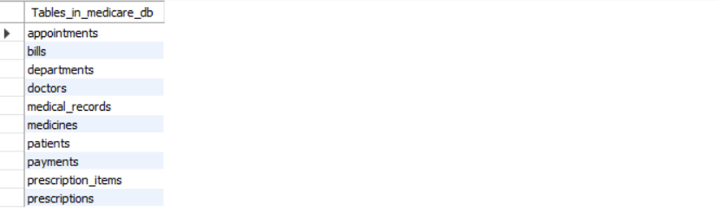

Screenshot 2: Row counts after INSERT – script 04
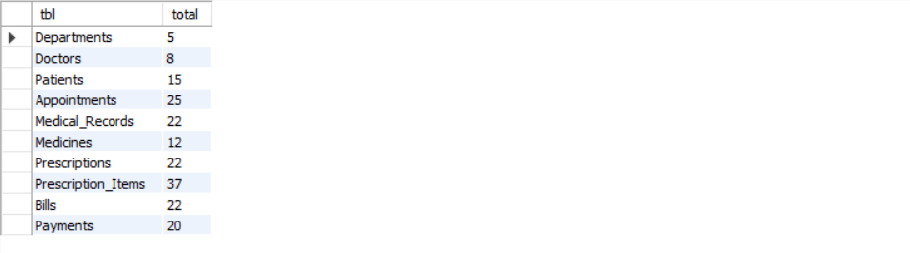

Screenshot 3: Joins output (J4 patient medical history) – script 06
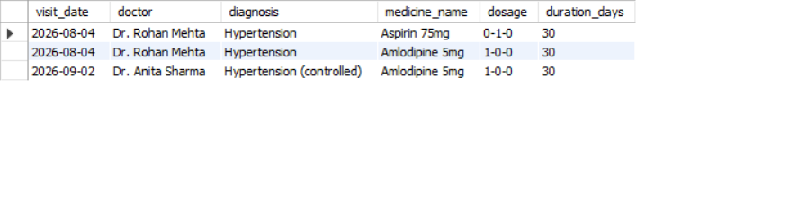

Screenshot 4: Aggregate analytics (A5 – A8) – script 08
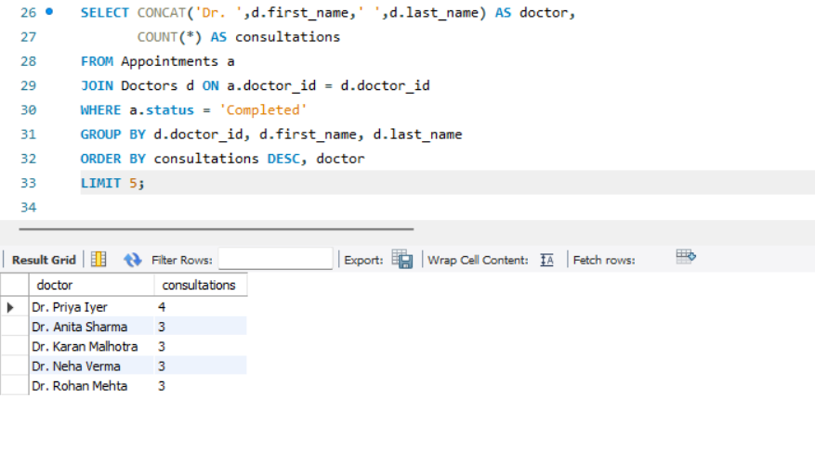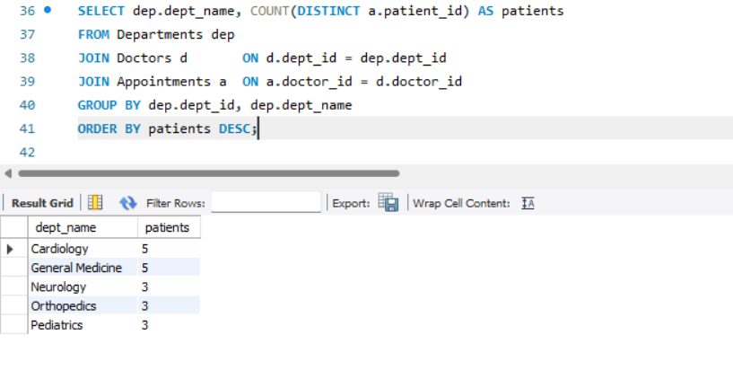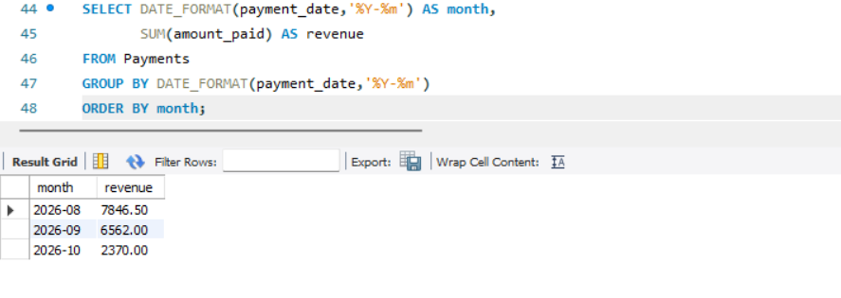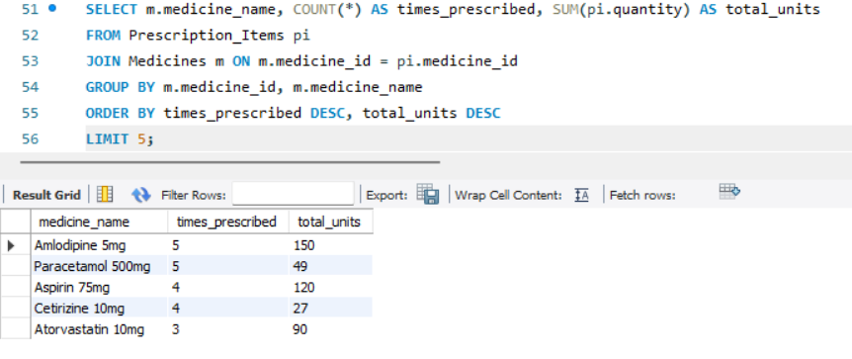

Screenshot 5: Transaction demo (COMMIT / ROLLBACK / SAVEPOINT and cancellation/rebooking) - script 09
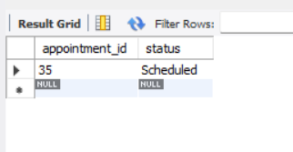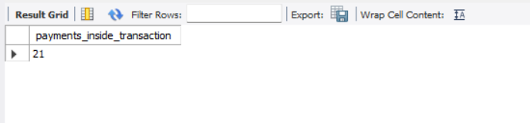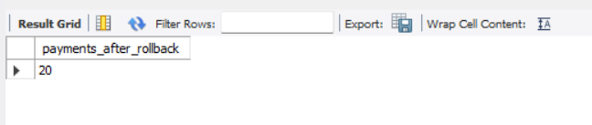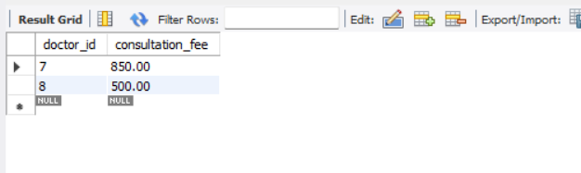

Screenshot 6: SHOW GRANTS output – script 10
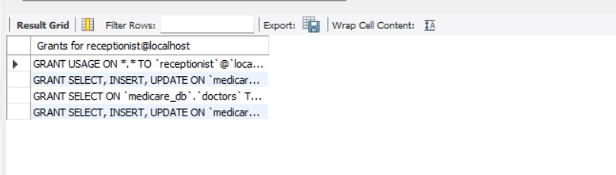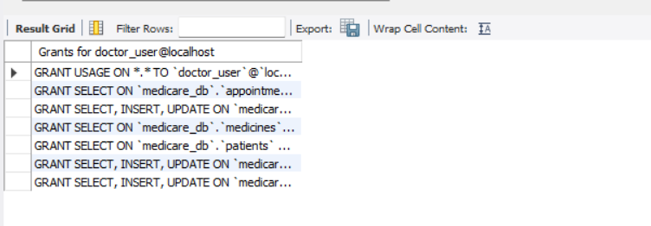
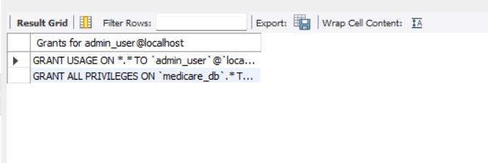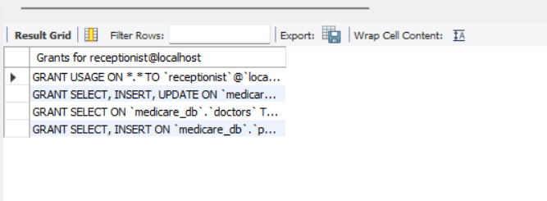

13. Conclusion
MediCare demonstrates a normalized hospital database with ten related tables supporting the workflow from patient registration to billing and payment. Primary keys, foreign keys, unique constraints and CHECK constraints protect data integrity. The generated appointment-status key prevents active double bookings while allowing cancelled slots to be reused. JOINs, subqueries, aggregate queries, transactions and access-control examples demonstrate practical SQL use. Payment status is reconciled by an explicit SQL update; automatic trigger-based updates remain future work.

14. Future Scope
- Java + JDBC or web front end for receptionists and doctors.
- Triggers to calculate bill totals and update payment status automatically.
- Pharmacy stock tracking and low-stock alerts.
- Inpatient admission, ward and bed management.
- Insurance claims and online appointment booking.
- Database backup and audit logging.

15. References / Research Sources
- Oracle, MySQL 8.0 Reference Manual (constraints, generated columns, transactions and stored programs) - https://dev.mysql.com/doc/refman/8.0/en/ (accessed 11 November 2026).
- Oracle, MySQL Workbench Manual – https://dev.mysql.com/doc/workbench/en/ (accessed 11 November 2026).
- Elmasri, R. and Navathe, S., Fundamentals of Database Systems, Pearson.
- Silberschatz, A., Korth, H. and Sudarshan, S., Database System Concepts, McGraw-Hill.
- W3Schools SQL Tutorial – https://www.w3schools.com/sql/ (accessed 11 November 2026).
- diagrams.net documentation – https://www.diagrams.net/doc/ (accessed 11 November 2026).

